**What is an IDE**

An Integrated Development Environment (IDE) is an application that facilitates application development. In general, an IDE is a graphical user interface (GUI)-based workbench designed to aid a developer in building software applications with an integrated environment combined with all the required tools at hand.Most common features, such as debugging, version control and data structure browsing, help a developer quickly execute actions without switching to other applications. Thus, it helps maximize productivity by providing similar user interfaces (UI) for related components and reduces the time taken to learn the language. An IDE supports single or multiple languages.Selecting a good IDE is based on factors, such as language support, operating system (OS) needs and costs associated with using the IDE etc.

**Eclipse**

Languages: C, C++, Python, Perl, PHP, Java, Ruby and more

Price: FREE

Eclipse is the free and open-source editor upon which many development frameworks are based. It's one of the granddaddies in its field and comes highly recommended by many a professional developer. Eclipse began as a Java development environment and has greatly expanded through a system of lightweight plugins.

**NetBeans**

Languages: Java, JavaScript, PHP, Python, Ruby, C, C++ and more

Price: FREE

NetBeans is neck-and-neck with Eclipse as the most-recommended IDE in this category. It's free and open-source, supports tons of languages with more plugins coming all the time, and is incredibly simple to install and use, even for a beginner.

**Komodo**

Languages: Perl, Python, Tcl, PHP, Ruby, Javascript and more

Price: $295

This enterprise-level tool might be best for the pro developer because of its higher price point. For beginners, you might also want to check out the Komodo-based, FOSS editor Open Komodo or Komodo's FOSS version, Komodo Edit.

**What Makes Any Coding Environment Good For Python Programming Language?**

Although, there are a lot of features which every developer should look in an IDE but the notable ones are:

* Ability to save and reload code files
* Run code from within the environment
* Debugging support
* Syntax highlighting
* Auto code formatting

**Python Specific Editors**

**1. PyCharm**

Category- IDE

Platform- Windows, Linux and Mac

Features:

* Intelligent code editor and smart code navigation
* Integrated with debugging, testing, deployments, tools of the database and other features.
* Supports JavaScript, HTML, CSS, Angular JS and other languages
* Error detection and quick fixing
* Powerful integration with IPython notebook and scientific stack
* Customizable interface
* Rich Community

Cons:

* Slow to load
* Default settings may need tweaking
* Initial installation might be difficult

**2. Visual Studio Code**

Category- Code Editor

Platform- Windows, Linux and Mac

A lot of people confuses Visual Studio Code with Visual Studio. Well, Visual Studio and Visual Studio Code are two different things. Visual Studio is a complete IDE whereas, Visual Studio Code (aka VSC or VS Code) is a full-featured code editor. VSC is a light, extensible, highly configurable and open-source editor. Similar to Atom, VSC is also built on Atom and can be used for many programming languages including Python. In fact, installing Python is very easy which makes this editor popular among Python developers.  
Features:

* Syntax highlighting
* Auto code completion with IntelliSense, snippets and code refactoring
* Powerful debugger
* Git integration
* Easy customization
* Completely portable
* Multi-language support
* Smart interface

Cons:

* Slow searching
* Longer launch time
* Lacks some features of a complete IDE

**Exhaustive list of Python IDEs (Alphabetically)**

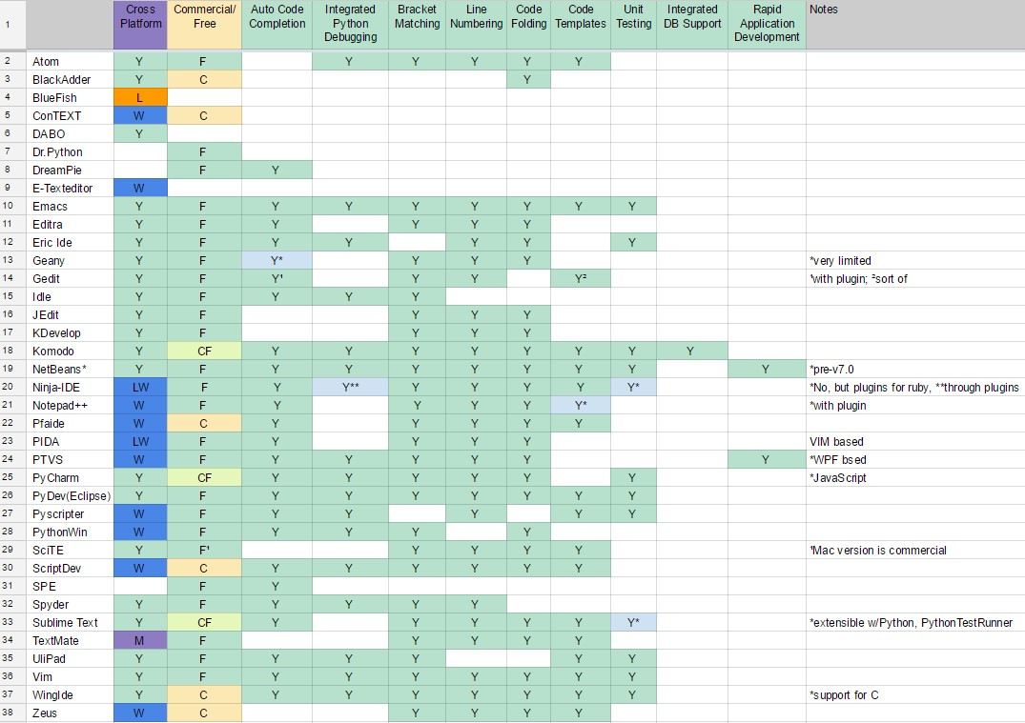

**Acronyms used :**

L  - Linux

W  - Windows

M  - Mac

C  - Commercial

F  - Free

CF - Commercial with Free limited edition

?  - To be confirmed

References:

<https://www.techradar.com/best/best-ide-for-python>

<https://www.veracode.com/security/integrated-development-environment>

<https://realpython.com/python-ides-code-editors-guide/>